PROJECT DOCUMENTATION
Content Gen - AI Blog Nest API

Team ID: SWTID-2026-8201
Team Size: 5
Team Leader: PADMA PRIYA M
Email: padma.priya.m24@gmail.com
Team member: NITHYA SHREE B
Email: b.nithyashree25@gmail.com
Team member: PADMA R
Email: padmaram2251@gmail.com
Team member: PAVITHRA S
Email: pavithrasankar74@gmail.com
Team member: PINKI B
Email: pinkibhagarambhati.b@gmail.com

PROJECT DOCUMENTATION
Content Gen - Generate high-quality blog
content using AI

Project Description :
AI Blog Nest API is a backend system designed to manage blog content through RESTful APIs. It provides features for creating, updating, viewing, and managing blog posts efficiently. The application is developed using Node.js and Express.js for server-side processing and API handling. MongoDB is used to store user details, blog information, and other application data. Mongoose provides structured data models and supports communication with the MongoDB database. Google Gemini AI is integrated to assist in generating blog content and summarizing existing content.
The system supports secure user authentication and role-based access for different users. The API architecture separates routes, controllers, models, and services for better organization. Postman can be used to test the API endpoints and verify their responses. Overall, AI Blog Nest API combines backend technologies with AI capabilities to simplify and improve blog content management.
Scenario-Based Case Study
Background:
Arun is a content creator who regularly publishes blog posts and manages different types of content. He needs a simple and secure platform to create blogs, organize content, manage comments, and generate useful content quickly. Creating and summarizing blog content manually takes considerable time, especially when managing multiple posts. The AI Blog Nest API provides a centralized backend solution with AI-assisted features to simplify these activities.

Problem:
- Difficulty in creating high-quality blog content within a short time.
- Managing multiple blog posts and content details manually.
- Time-consuming process of writing and summarizing lengthy content.
- Difficulty managing categories, tags, and comments efficiently.
- Need for secure authentication and role-based access.
- Requirement for a structured backend API to handle blog-related operations.
Solution:
The AI Blog Nest API provides a centralized and secure backend system for managing blog content through RESTful API endpoints. It uses Node.js and Express.js for backend operations and MongoDB with Mongoose for data storage and management. Google Gemini AI is integrated to assist with blog generation and content summarization. JWT authentication and role-based access control help protect restricted operations and ensure that users can access only the features permitted for their roles.
Usage:
- Author Usage: Creates and manages blog posts, organizes content, and uses AI-assisted features to generate and summarize blog content.
- Editor/Admin Usage: Reviews and manages blog content, handles comments and categories, and controls user permissions through protected endpoints.
- Reader Usage: Accesses published blog posts and interacts with available content and comment features.
Outcome
The AI Blog Nest API reduces the time required for blog creation and content management by providing AI-assisted functionality through a centralized backend. It improves data organization through structured database models and provides secure access using authentication and role-based authorization. The system also makes blog content easier to create, manage, and summarize while providing a scalable foundation for future enhancements.

1.Software Requirements:
- Operating System: Windows, macOS, or Linux environment.
- Development Environment: Visual Studio Code for writing, editing, and organizing project files.
- Runtime: Node.js for running the backend application.
- Backend Framework: Express.js for creating and managing REST API services.
- Database: MongoDB for storing user and blog-related information.
- Database Tool: Mongoose for defining schemas and handling database operations.
- AI Service: Google Gemini AI for AI-assisted blog generation and content summarization.
- API Testing Tool: Postman for sending API requests and checking server responses.
- Package Manager: npm for installing and managing the project dependencies.
2.Hardware Requirements:
- Processor: Intel Core i3 or an equivalent processor.
- Memory: Minimum 4 GB RAM for basic project development and execution.
- Storage: Minimum 500 MB free space for the application files and required packages.
- Display: Standard monitor or laptop display for working with the development environment.
- Internet: Stable internet connection for AI service access and package installation.
- Computer: A laptop or desktop system capable of running the required development software.
Epic:-1 PROJECT ARCHITECTURE:
The AI Blog Nest API follows a structured backend architecture that connects the client application, server, database, and AI services. The Express.js server receives requests from the client through RESTful API endpoints and processes them according to the required operation. The service layer handles blog management operations and AI-based functions such as content generation and summarization. Mongoose acts as the database interface and connects the application with MongoDB for storing and retrieving user and blog information. After processing the request, the server sends the appropriate response back to the client.
This modular architecture makes the backend easier to organize, maintain, and extend with additional features in the future.
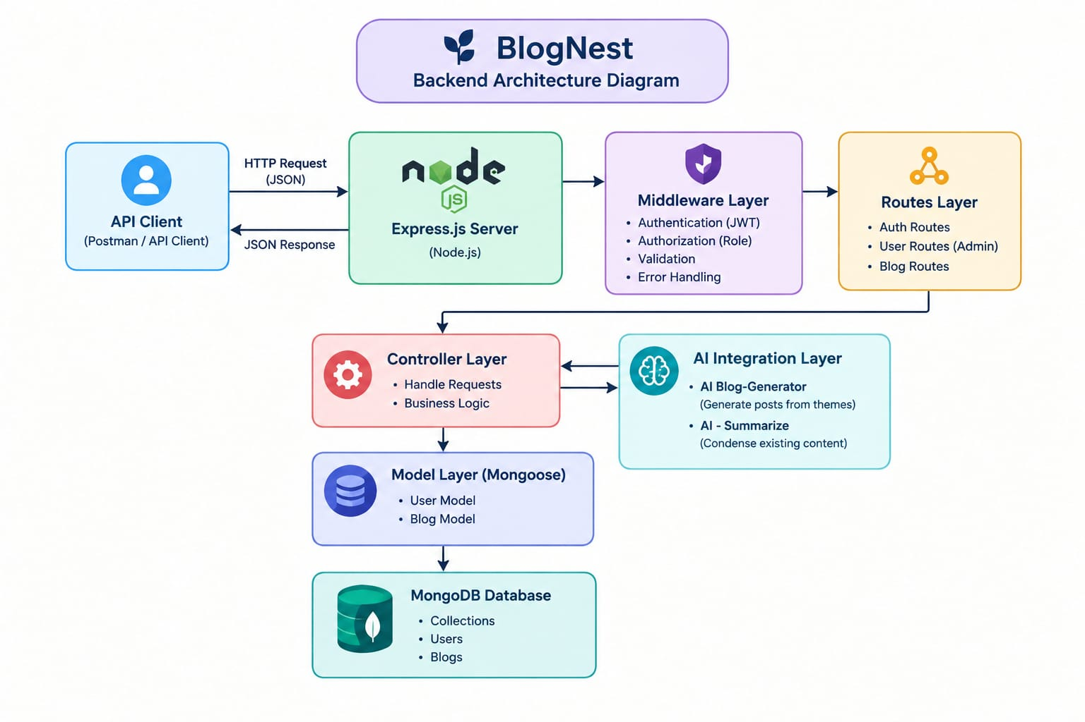

The AI Blog Nest API uses a layered backend architecture to provide secure and efficient blog management. API requests pass through different layers before interacting with the database and AI services.
System Components:
- API Interface: Postman or other API clients are used to send requests to the available Blog Nest API endpoints and receive structured responses from the backend.
- Express Server: The Express.js server receives HTTP requests, manages API routes, processes JSON data, and sends responses to the client application.
- Authentication & Authorization Layer: This layer verifies user authentication and controls access to protected resources according to the user's assigned role.
- Controller Layer: Controllers receive requests from the routes and coordinate the required operations by communicating with the service and database layers.
- Service Layer: The service layer contains the main application logic for blog management and handles operations required to process user requests.
- Database Layer: Mongoose connects the backend application with MongoDB and manages the storage and retrieval of user and blog information.
- AI Integration Layer: This layer connects the backend with Google Gemini AI to provide features such as AI-assisted blog generation and content summarization.
- Response Handler: After completing the requested operation, the backend prepares the processed information and returns an appropriate response to the API client.
Entity-Relationship (ER) Diagram Description:
The AI Blog Nest API uses a structured database design to manage users, blog posts, comments, and their relationships.
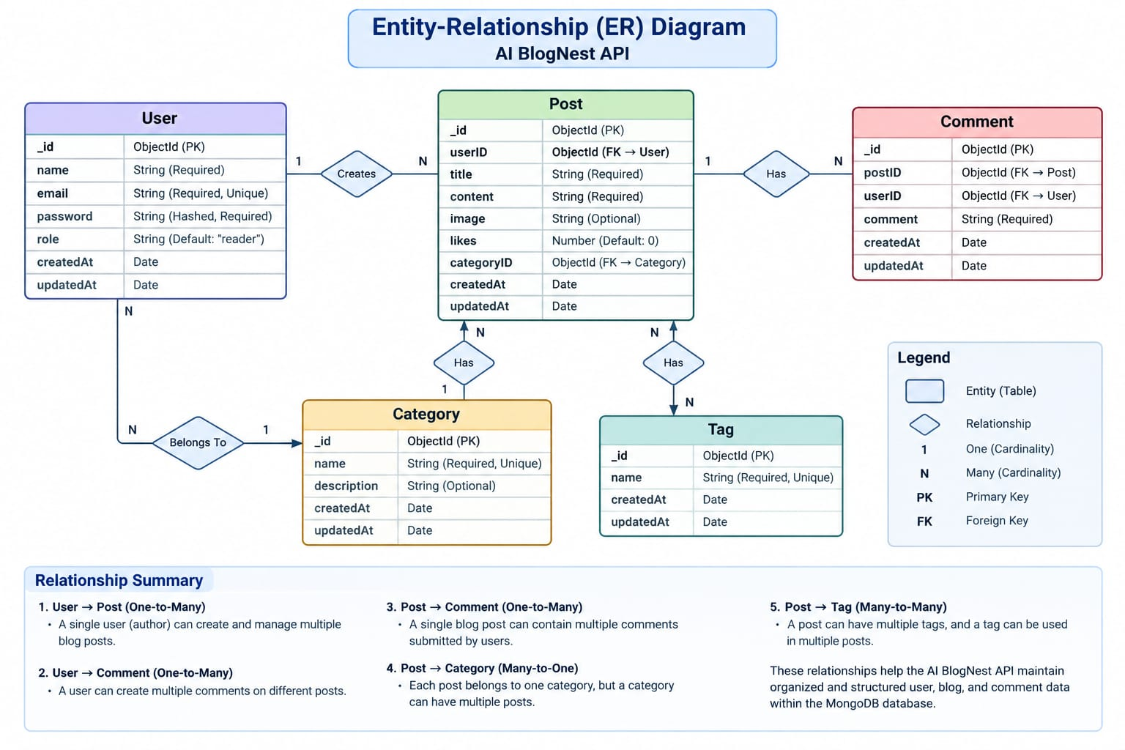
- User Entity:
- _Id: Primary Key – Object Id
- name: String, Required
- email: String, Required, Unique
- password: String, Hashed, Required
- role: String, Default: "reader"
2. Post Entity:
- _Id: Primary Key – Object Id
- user ID: Foreign Key referencing User Collection
- name: String, Required – represents the blog title
- photo: Object/String – represents the media or image path
- message: String – represents the main blog content
- likes: Number, Default: 0
- timestamps: Enabled for tracking creation and update times
Key Structural Mappings:
- User to Post (One-to-Many): A single user, particularly an author, can create and manage multiple blog posts.
- User to Comment (One-to-Many): A user can create multiple comments on different blog posts.
- Post to Comment (One-to-Many): A single blog post can contain multiple comments submitted by users.
Key Functionalities:
- User Authentication: Provides secure login and user verification for accessing the API.
- Role-Based Access: Controls system operations according to the user's assigned role.
- Blog Management: Allows users to create, view, update, and manage blog content through API operations.
- Content Organization: Supports structured management of blog information for easier access and maintenance.
- Comment Management: Provides functionality for handling comments associated with blog posts.
- AI Blog Generation: Uses Gemini AI to assist in generating blog content from user-provided topics or inputs.
- AI Content Summarization: Helps create concise summaries from longer blog content.
- Database Management: Uses MongoDB and Mongoose to store and manage application data.
- API Testing: Supports testing of backend endpoints using tools such as Postman.
- Secure Data Handling: Uses validation and security mechanisms to protect backend operations and maintain data integrity.
Roles and Responsibilities:
- Admin: Has complete control over the system. The Admin can manage user accounts, assign or update user roles, manage blog content, moderate comments, and monitor system activities.
- Editor: Responsible for reviewing and managing blog content. The Editor can review submitted posts, manage publishing status, organize categories, and moderate content before publication.
- Author: Can create and manage blog posts associated with their own account. The Author can use AI-assisted features to generate and summarize blog content and update their posts.
- Reader: Can access published blog posts and read available content. The Reader can also add comments to blog posts according to the permissions provided by the system.

User Flow:
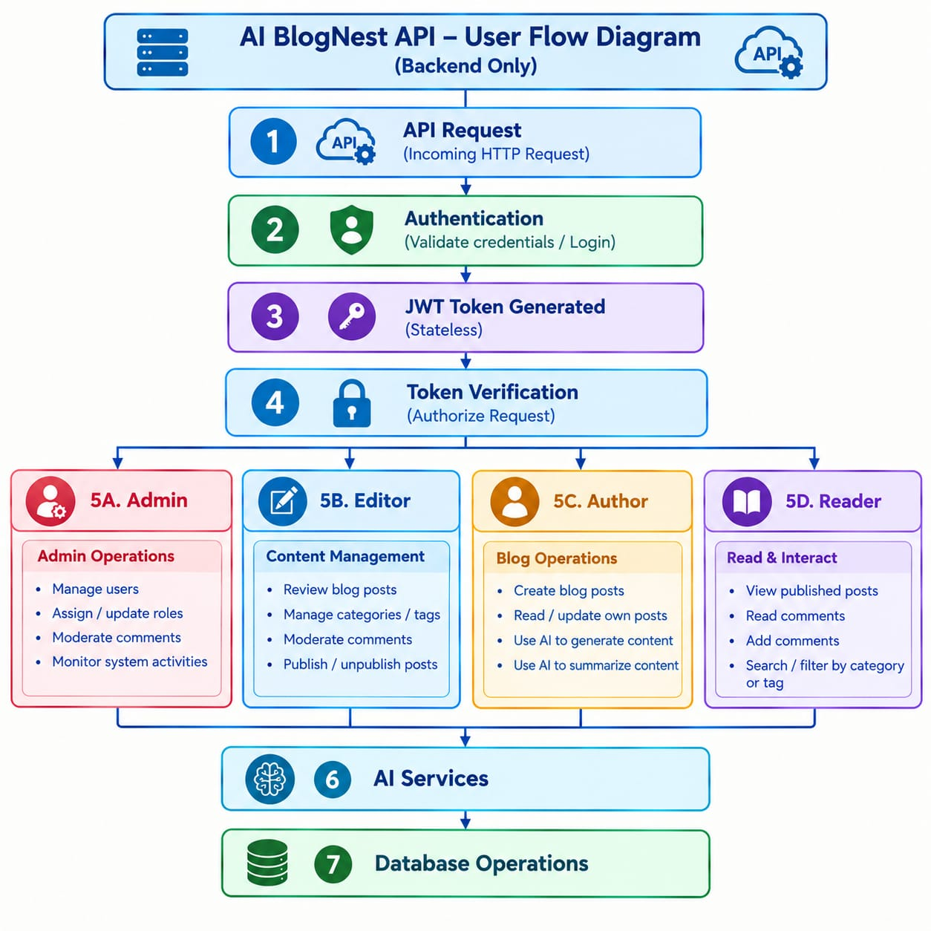
MVC Architecture Pattern:
The AI Blog Nest API is organized using the MVC architecture to separate different backend responsibilities. This makes the application easier to understand, develop, test, and maintain. The architecture divides the backend into three main parts: Model, Controller, 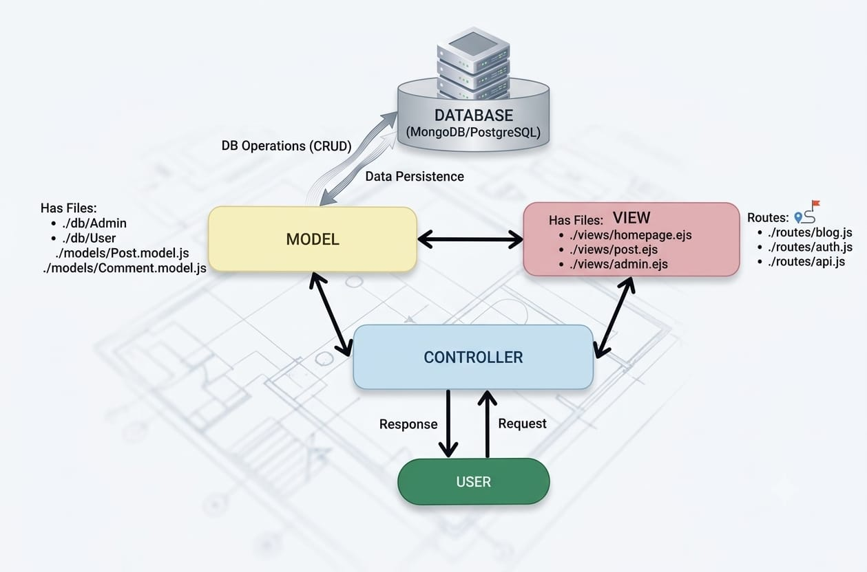
1. Model:
The Model manages the structure and storage of application data. It defines schemas for users and blog posts and communicates with MongoDB through Mongoose.
2.Controller:
The Controller acts as the processing layer of the application. It receives requests from the routes, performs the required operations, interacts with the Model, and prepares the result.
3.View:
In AI Blog Nest API, there is no traditional web page-based View because it is a REST API backend. The View is represented through the API responses returned to the client in a structured format.
Epic2: Project Initialization:
The initial project setup involves creating the required project structure and preparing the backend development environment. A separate project folder is created for the AI Blog Nest API and opened using Visual Studio Code. The Node.js environment is initialized using npm to create the project configuration file. Required backend folders are then organized to separate different parts of the application.
Project Folder Setup:
1.Create a new folder for the AI Blog Nest API project.
2.Open the project folder in Visual Studio Code.
3.Initialize the Node.js project using the npm command.
4.Create the main server file for running the backend application.
5.Create separate folders for models, controllers, routes, and services.
6.Configure the required dependencies for the backend development.

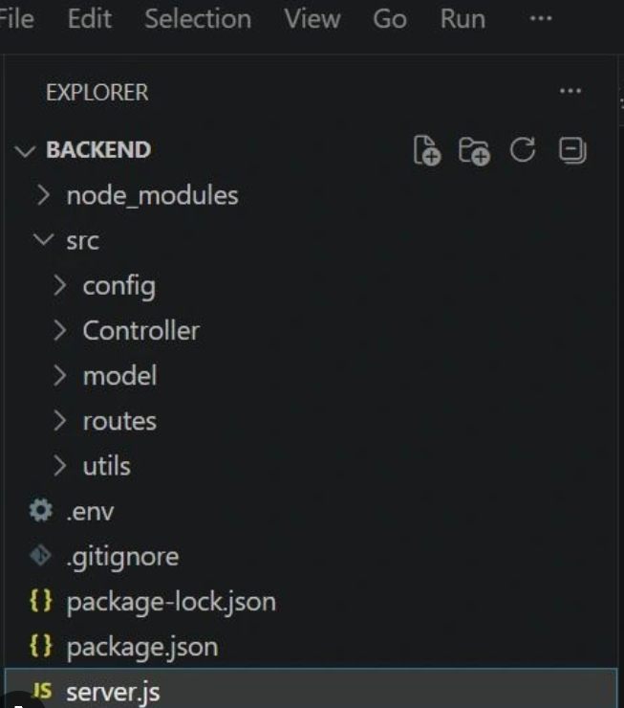

Epic3: Backend Configuration:

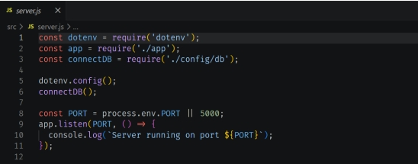

Epic4: Database Integration:
1.Install Mongoose
Install Mongoose to connect the Node.js application with MongoDB.
2. Establish Database Connection
Configure the MongoDB connection so the backend can communicate with the database.
3. Create Schemas and Models
Define schemas and models for storing and managing user and blog-related data.
4. Perform Database Operations
Use the models to store, retrieve, update, and manage application data efficiently.
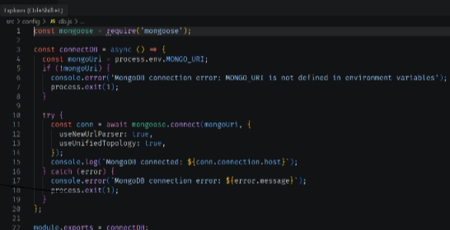

Epic5: Project Executions:
- Install Postman or Thunder Client (VS Code extension).

- Start the backend server:
“npm start”

API Testing:
User Registration :

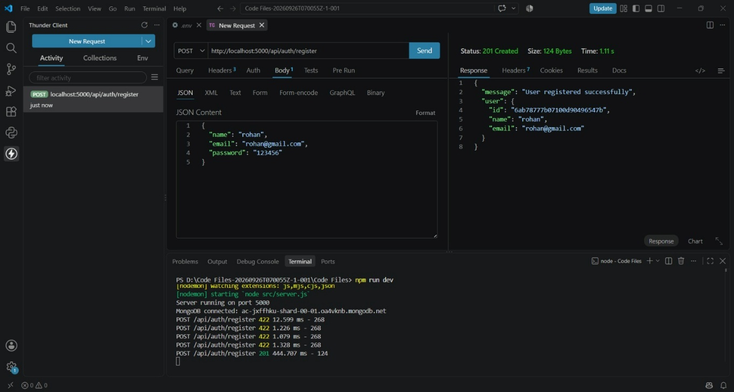
User L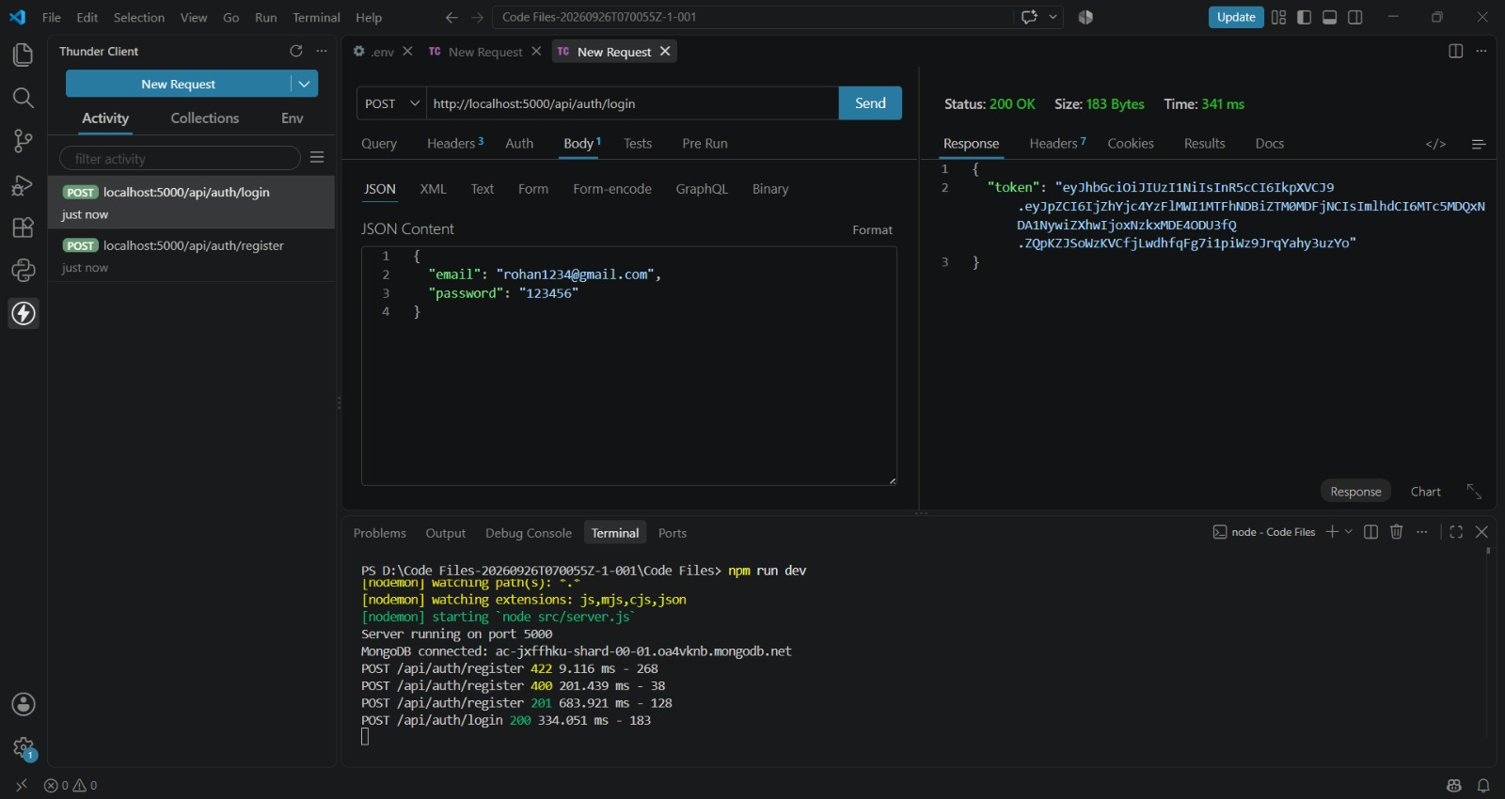
Post blogs: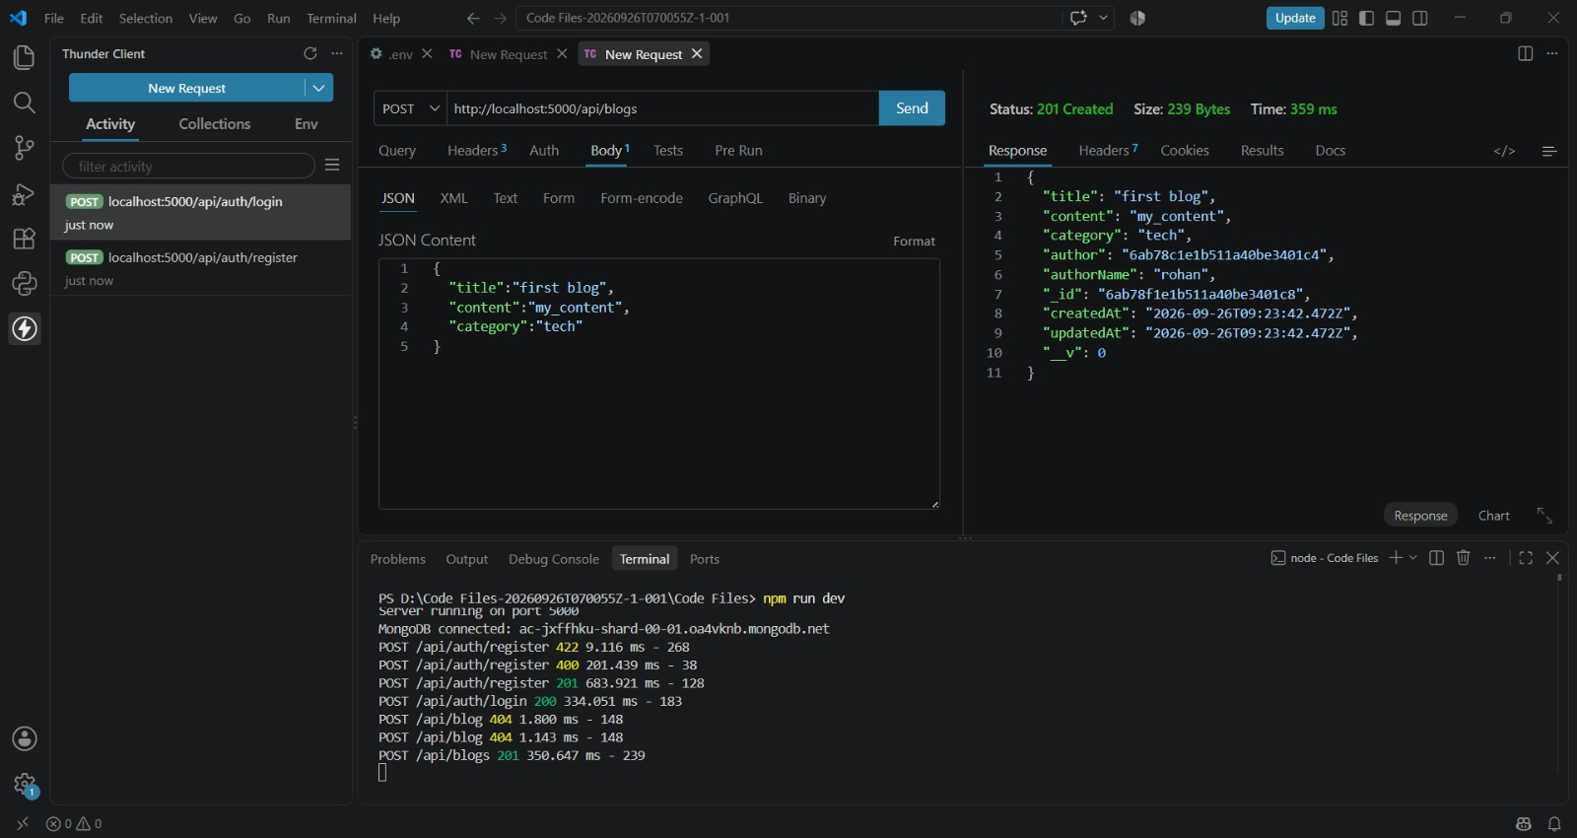

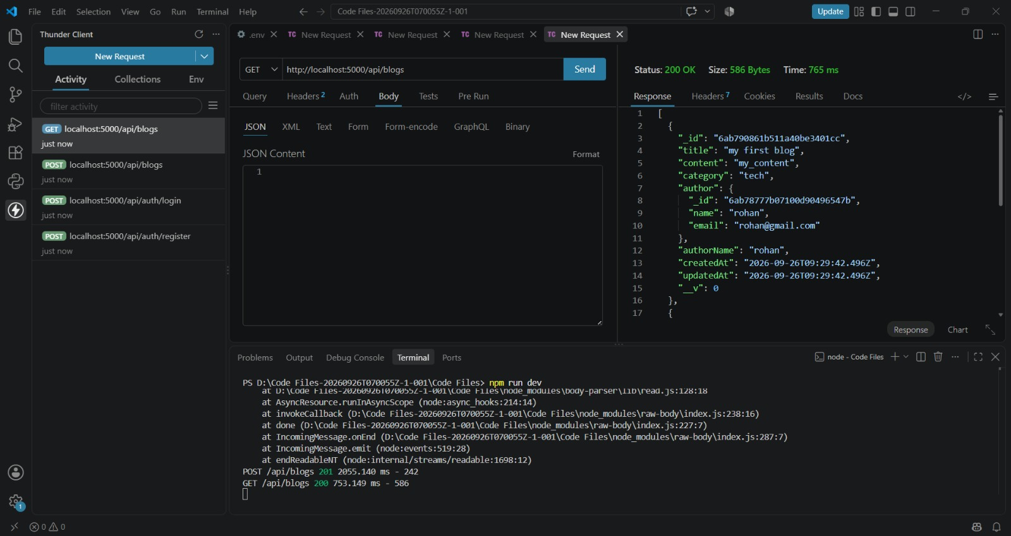
Get blogs:
Generate AI blog:

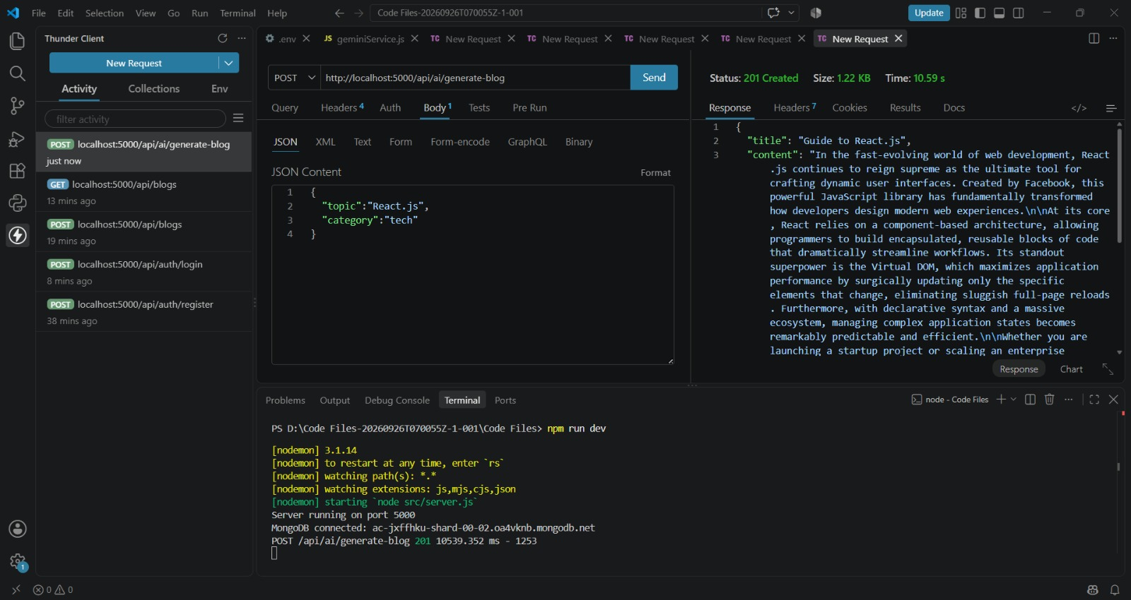
Summarize:

